> **ec1:=diff(x(t),t)=x(t)+4*y(t);**



> **ec2:=diff(y(t),t)=x(t)+y(t);**



> **sist:=ec1,ec2;**



> **with(DEtools):with(plots):**

> **dsolve({sist},{x(t),y(t)});**



> **ec1:=diff(x(t),t)=2*x(t)-y(t);**



> **ec2:=diff(y(t),t)=x(t)+2*y(t);**



> **sist:=ec1,ec2;**



> **dsolve({sist},{x(t),y(t)});**



> **ec1:=diff(x(t),t)=x(t)-y(t)+z(t);**



> **ec2:=diff(y(t),t)=x(t)+y(t)-z(t);**



> **ec3:=diff(z(t),t)=-y(t)+2*z(t);**



> **sist:=ec1,ec2,ec3;**



> **dsolve({sist},{x(t),y(t),z(t)});**



>

> **ec1:=diff(x(t),t)=3*x(t)-y(t)+z(t);**



> **ec2:=diff(y(t),t)=2*x(t)+z(t);**



> **ec3:=diff(z(t),t)=x(t)-y(t)+2*z(t);**



> **sist:=ec1,ec2,ec3;**



> **dsolve({sist},{x(t),y(t),z(t)});**

>



> **ec1:=diff(x(t),t)=5*x(t)+3*y(t)+1;**



> **ec2:=diff(y(t),t)=-6*x(t)-4*y(t)+exp(t);**



> **sist:=ec1,ec2;**

> **dsolve({sist},{x(t),y(t)});**





> **ec1:=diff(x(t),t)=x(t)+3*y(t)+cos(t);**



> **ec2:=diff(y(t),t)=x(t)-y(t)+2*t;**



> **sist:=ec1,ec2;**

> **dsolve({sist},{x(t),y(t)});**





>

> **ec1:=diff(x(t),t)=x(t)-2*y(t)-2*z(t)+exp(-t);**



> **ec2:=diff(y(t),t)=-2*x(t)+y(t)+2*z(t);**



> **ec3:=diff(z(t),t)=2*x(t)-y(t)-3*z(t)+exp(t);**



> **sist:=ec1,ec2,ec3;**

>



> **dsolve({sist},{x(t),y(t),z(t)});**



>

> **ec1:=diff(x(t),t)=-x(t)+3*y(t)-4*z(t)+25*t;**



> **ec2:=diff(y(t),t)=-2*x(t)-6*z(t)+12*exp(t);**



> **ec3:=diff(z(t),t)=-2*x(t)-6*y(t)+6*z(t)+12;**



> **sist:=ec1,ec2,ec3;**



> **dsolve({sist},{x(t),y(t),z(t)});**



>

> **ec1:=diff(x(t),t)=x(t)+4*y(t);**



> **ec2:=diff(y(t),t)=x(t)+y(t);**



> **cond_in:=x(0)=1,y(0)=2;**



> **sist:=ec1,ec2;**



> **sol:=dsolve({sist,cond_in},{x(t),y(t)});**



> **xx:=unapply(rhs(sol[1]),t);**



>  **yy:=unapply(rhs(sol[2]),t);**



>  **plot([xx(t),yy(t)],t=2..5,color=[red,blue]);**

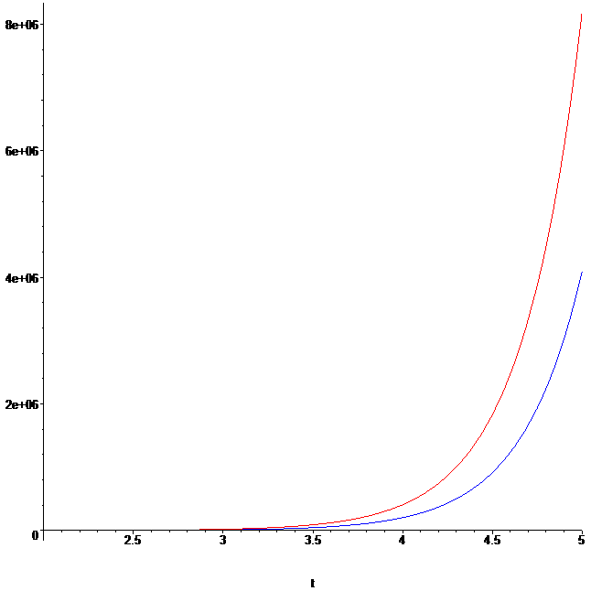

>

> **ec1:=diff(x(t),t)=x(t)-y(t)+t-1;**



> **ec2:=diff(y(t),t)=-2*x(t)+4*y(t)+exp(t);**



> **cond_in:=x(0)=0,y(0)=1;**



> **sist:=ec1,ec2;**



> **sol:=dsolve({sist,cond_in},{x(t),y(t)});**



> **xx:=unapply(rhs(sol[1]),t);**



>  **yy:=unapply(rhs(sol[2]),t);**



>  **plot([xx(t),yy(t)],t=2..5,color=[red,blue]);**

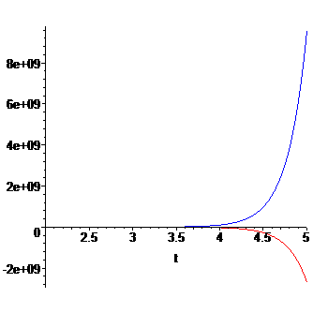

>

> **ec1:=diff(x(t),t)=x(t)+2*y(t)+exp(-t);**



> **ec2:=diff(y(t),t)=-2*x(t)+y(t)+1;**



> **cond_in:=x(0)=0,y(0)=1;**



> **sist:=ec1,ec2;**



> **sol:=dsolve({sist,cond_in},{x(t),y(t)});**



> **xx:=unapply(rhs(sol[1]),t);**



>  **yy:=unapply(rhs(sol[2]),t);**



>  **plot([xx(t),yy(t)],t=2..5,color=[red,blue]);**

> **ec1:=diff(x(t),t)=x(t)+2*y(t)+exp(-t);**



> **ec2:=diff(y(t),t)=-2*x(t)+y(t)+1;**



> **cond_in:=x(0)=0,y(0)=1;**



> **sist:=ec1,ec2;**



> **sol:=dsolve({sist,cond_in},{x(t),y(t)});**



> **xx:=unapply(rhs(sol[1]),t);**



>  **yy:=unapply(rhs(sol[2]),t);**



>  **plot([xx(t),yy(t)],t=2..5,color=[red,blue]);**

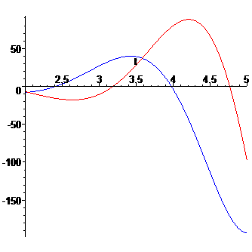

>

> **ec1:=diff(x(t),t)=-x(t)+3*y(t)+3*z(t)+27*t^2;**



> **ec2:=diff(y(t),t)=2*x(t)-2*y(t)-5*z(t)+3*t;**



> **ec3:=diff(z(t),t)=-2*x(t)+3*y(t)+6*z(t)+3;**



> **cond_in:=x(0)=50,y(0)=-30,z(0)=26;**



> **sist:=ec1,ec2,ec3;**



> **sol:=dsolve({sist,cond_in},{x(t),y(t),z(t)});**



> **xx:=unapply(rhs(sol[1]),t);**



>  **yy:=unapply(rhs(sol[2]),t);**



> **zz:=unapply(rhs(sol[3]),t);**



>  **plot([xx(t),yy(t),zz(t)],t=2..3,color=[red,yellow,orange]);**

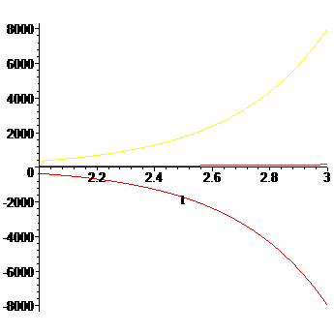

>

> **ec1:=diff(x(t),t)=x(t)+y(t);**

> **ec2:=diff(y(t),t)=-2*x(t)+4*y(t);**





> **cond_in:=x(0)=3,y(0)=0;**



> **sist:=ec1,ec2;**



> **sol:=dsolve({sist,cond_in},{x(t),y(t)});**



> **xx:=unapply(rhs(sol[1]),t);**



>  **yy:=unapply(rhs(sol[2]),t);**



>  **plot([xx(t),yy(t)],t=2..5,color=[red,blue]);**

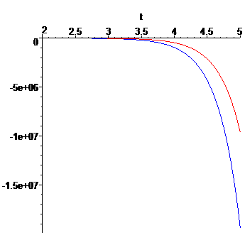

> **limit(sol[1],t=infinity);**



> **limit(sol[2],t=infinity);**



> **cond_in:=x(0)=2,y(0)=3;**



> **sist:=ec1,ec2;**



> **sol:=dsolve({sist,cond_in},{x(t),y(t)});**



> **xx:=unapply(rhs(sol[1]),t);**



>  **yy:=unapply(rhs(sol[2]),t);**



>  **plot([xx(t),yy(t)],t=2..5,color=[red,blue]);**

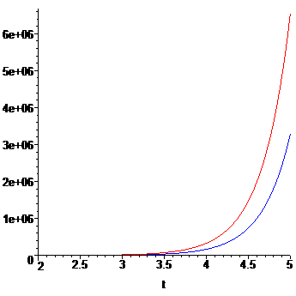

> **limit(sol[1],t=infinity);**



> **limit(sol[2],t=infinity);**



>

> **cond_in:=x(0)=-3,y(0)=0;**



> **sist:=ec1,ec2;**



> **sol:=dsolve({sist,cond_in},{x(t),y(t)});**



> **xx:=unapply(rhs(sol[1]),t);**



>  **yy:=unapply(rhs(sol[2]),t);**



>  **plot([xx(t),yy(t)],t=2..5,color=[red,blue]);**

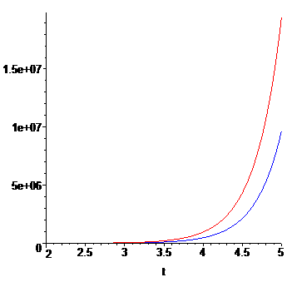

> **limit(sol[1],t=infinity);**



> **limit(sol[2],t=infinity);**



>

>

> **cond_in:=x(0)=-2,y(0)=-3;**



> **sist:=ec1,ec2;**



> **sol:=dsolve({sist,cond_in},{x(t),y(t)});**



> **xx:=unapply(rhs(sol[1]),t);**



>  **yy:=unapply(rhs(sol[2]),t);**



>  **plot([xx(t),yy(t)],t=2..5,color=[red,blue]);**

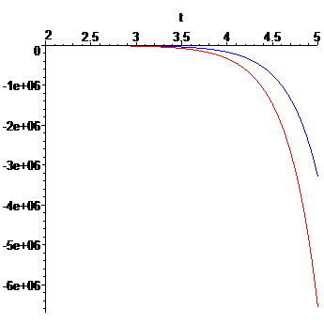

> **limit(sol[1],t=infinity);**



> **limit(sol[2],t=infinity);**



>

>  **DEplot([sist],[x(t),y(t)],t=-4..4,x=-10..10,y=-10..10, [[x(0)=3,y(0)=0], [x(0)=2,y(0)=3], [x(0)=-3,y(0)=0],[x(0)=-2,y(0)=-3]],arrows=medium, linecolor=blue,stepsize=0.1);**

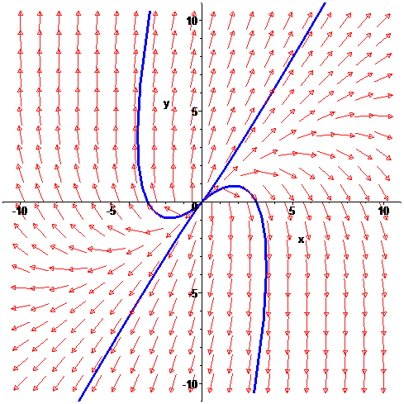

>

>

> **ec1:=diff(x(t),t)=y(t);**

> **ec2:=diff(y(t),t)=-x(t)-2*y(t);**





>



> **sist:=ec1,ec2;**



> **sol:=dsolve({sist},{x(t),y(t)});**



> **limit(sol[1],t=infinity);**



> **limit(sol[2],t=infinity);**



> **DEplot([sist],[x(t),y(t)],t=-4..4,x=-10..10,y=-10..10, arrows=medium);**

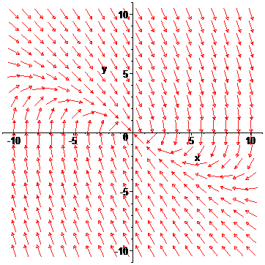

>

> **ec1:=diff(x(t),t)=2*x(t)+y(t);**

> **ec2:=diff(y(t),t)=x(t)+2*y(t);**





> **sist:=ec1,ec2;**



> **DEplot([sist],[x(t),y(t)],t=-4..4,x=-10..10,y=-10..10, arrows=medium);**

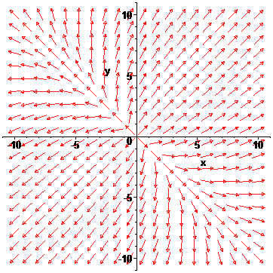

> **ec1:=diff(x(t),t)=-x(t)-y(t);**

> **ec2:=diff(y(t),t)=x(t)-y(t);**





> **sist:=ec1,ec2;**



> **DEplot([sist],[x(t),y(t)],t=-4..4,x=-10..10,y=-10..10, arrows=medium);**

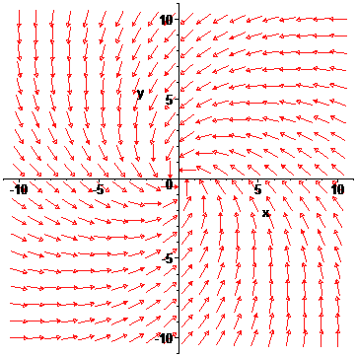

> **ec1:=diff(x(t),t)=y(t);**

> **ec2:=diff(y(t),t)=-x(t);**





> **sist:=ec1,ec2;**



> **DEplot([sist],[x(t),y(t)],t=-4..4,x=-10..10,y=-10..10, arrows=medium);**

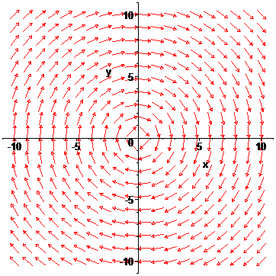

> **ec1:=diff(x(t),t)=-2*x(t);**

> **ec2:=diff(y(t),t)=-4*x(t)-2*y(t);**





> **sist:=ec1,ec2;**



> **DEplot([sist],[x(t),y(t)],t=-4..4,x=-10..10,y=-10..10, arrows=medium);**

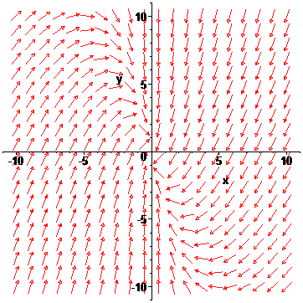

>

> **ec1:=diff(x(t),t)=x(t)-4*y(t);**

> **ec2:=diff(y(t),t)=5*x(t)-3*y(t);**





> **sist:=ec1,ec2;**



> **DEplot([sist],[x(t),y(t)],t=-4..4,x=-10..10,y=-10..10, arrows=medium);**

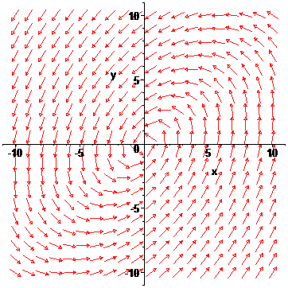

> **ec1:=diff(x(t),t)=3*x(t)-y(t);**

> **ec2:=diff(y(t),t)=y(t);**





> **sist:=ec1,ec2;**



> **DEplot([sist],[x(t),y(t)],t=-4..4,x=-10..10,y=-10..10, arrows=medium);**



